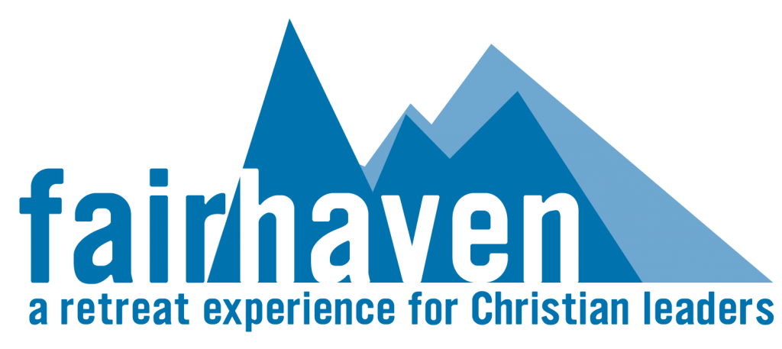
Group / Educational Retreats & Seminars

Focus:
- Leadership Development | - Emotional / Relational Health
- Spiritual Formation | - Creative Arts

Fairhaven is an ideal setting for an intimate staff or board retreat or a focused event for Christian leaders. Whether hosted by Fairhaven staff or coordinated by your team, our experienced staff can help plan and/or facilitate your needs.

Our six beautiful cottages provide a variety of housing options for overnight retreats and seminars. For day retreats, the maximum size of group we can host would be 30.

Who will this benefit:
- Denominational Leaders/Pastors
- Missionary Organizations
- Church Boards
- Para-Church Organizations
- Christian Counselling Associations
- Bible College and Seminary Leadership Teams
- Christian artists

Suggested spiritual practices:
- Regular times of
  - Bible/devotional readings
  - Prayer, listening, reflecting, and meditating
  - Rest
- Practice of the spiritual disciplines
- Engagement in spiritual formation exercises, e.g. Ignatian Daily Examen, Lectio Divina, etc.

What is included:
- Accommodation in one of our beautifully decorated cottages
- Provision of outlines for spiritual practices
- Use of the library and Lodge facilities
- Access to counselling, coaching, or spiritual guidance, upon request
- Access to our trail system
- Information on local activities

