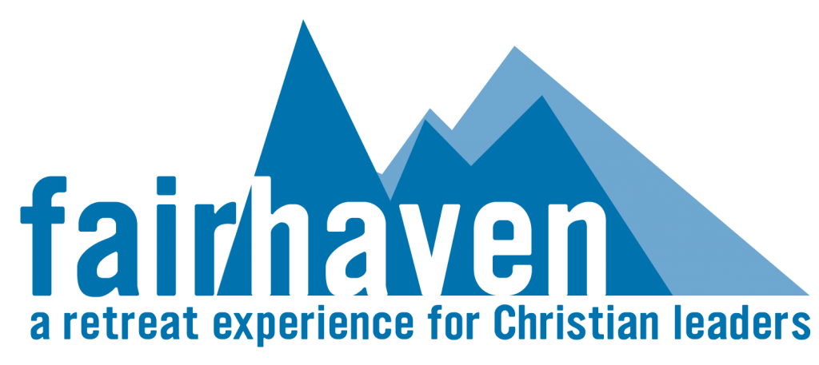
Self-Directed Retreat

Focus:
- Rest | - Personal or family directed experience
- Renewal

Who will this benefit:
The Personal / Family Directed Retreat is ideal for those seeking time to listen, pray,
read, meditate, write, rest, and enjoy nature as an individual, couple, or as a family.
The self-directed retreat provides an opportunity to unplug from the busyness of
one’s ministry in a context of prayer and solitude situated in the beautiful surroundings of the Fairhaven campus.
- Pastors
- Missionaries
- Para-Church leaders
- Christian Counsellors
- Faculty and staff at Bible Colleges and Seminaries
- Christian business leaders

Spiritual practices:
- Dedicated times of
  - Bible/devotional readings
  - Prayer, listening, reflecting, and meditating
  - Rest
- Practice of the spiritual disciplines
- Engagement in spiritual formation exercises, e.g. Ignatian Daily Examen, Lectio Divina, etc.
- Leisure activities

What is included:
- Accommodation in one of our beautifully decorated cottages
- Welcome Orientation and Q & A time
- Provision of outlines for spiritual practices
- Use of the library and Lodge facilities
- Access to Counselling, Coaching, Spiritual Guidance upon request
- Access to our trail system
- Information on local activities

