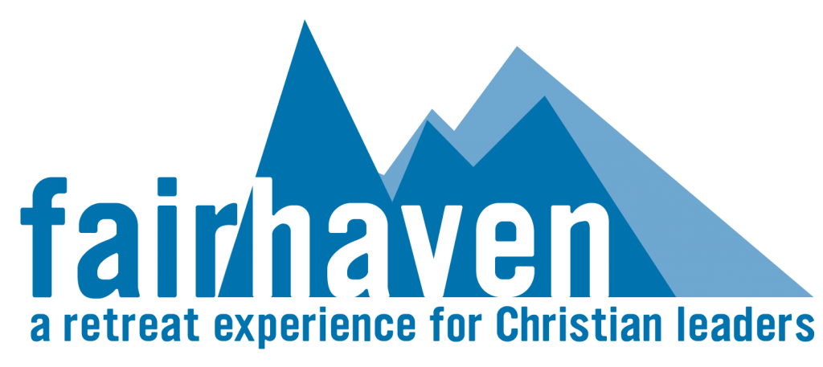
Leisure Sabbath

Focus:
- Leisure activities | - Renewal
- Rest

While the Fairhaven vision is aimed at the creation of intentional retreat experiences focused on spiritual health and renewal, the benefit of leisure-based activities, vacations, and recreational experiences cannot be underestimated. When vacancy permits, accommodations at Fairhaven can be requested when the focus of the stay is primarily for accommodation purposes.

The language of “leisure sabbath” verses “a vacation, ” or simply, “a holiday,” is used intentionally to encourage guests during their stay to also engage and benefit from the spiritual ethos of the retreat setting.

Who will this benefit:
- Pastors
- Missionaries
- Para-Church leaders
- Christian counsellors
- Faculty and staff at Bible Colleges and Seminaries
- Christian business leaders

Suggested spiritual practices:
- Leisure & recreational activities
- Times of
  - Bible/devotional readings
  - Prayer
  - Listening, reflecting, and meditating
  - Rest
- Practice of the spiritual disciplines
- Engagement in spiritual formation exercises, e.g. Ignatian Daily Examen, Lectio Divina, etc.

What is included:
- Accommodation in one of our beautifully decorated cottages
- Provision of outlines for spiritual practices
- Use of the library and Lodge facilities
- Access to counselling, coaching, or spiritual guidance, upon request
- Access to our trail system
- Information on local activities

